How to use flow of another project:

1. In existing project click the MAVEN ICON



1. Now import the “.jar” file and import the associated “pom.xml” file

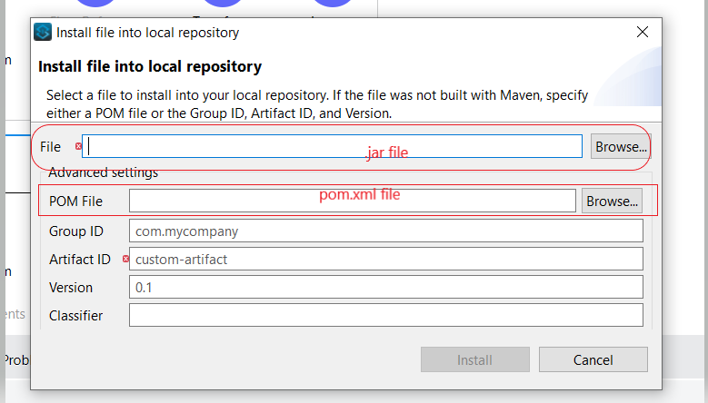

1. Once done add the dependency for the jar file in pom.xml of the current project

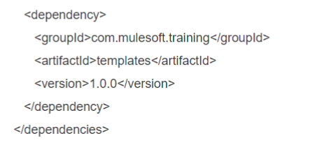

1. Once done save the file
2. Now open the “mule.xml” file of the project. Go to global configuration-> Import -> “mule.xml” file name

